VPK Supply List

1. Backpack
2. Change of clothes in a bag to be left in their cubby (just in case).
3. Water Bottle
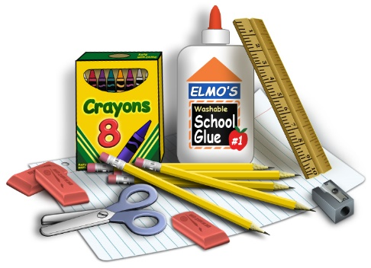
4. Rest blanket or towel
5. Glue sticks
6. Crayons

Classroom Wish List Items- Thank you for any donations

White Board Markers
Sanitizing wipes (Clorox or Lysol)
Tissues
Ziploc Bags (any size)
Paper Towels
Snacks (pretzels, goldfish, graham crackers, fruit snacks, animal crackers, rice krispy treats…)

